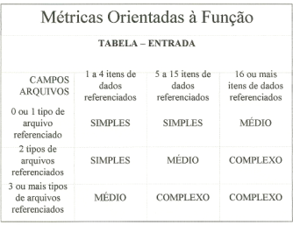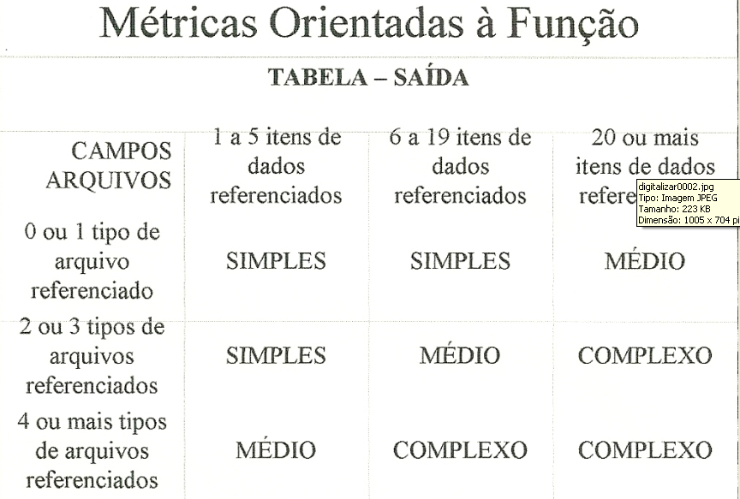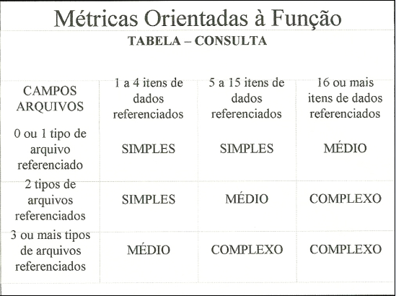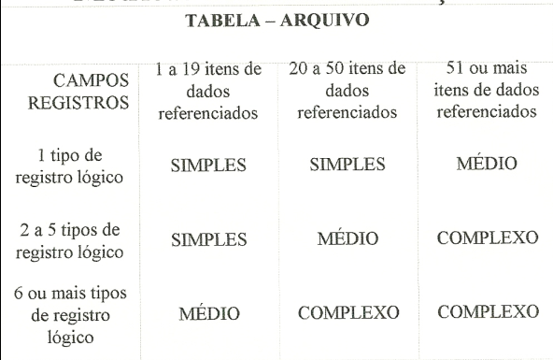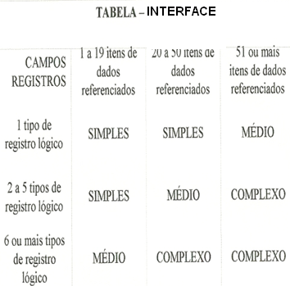

|  |  |  |  |  |  |  |  |  |  |  |  |  |  |  |  |  |  |  |  |  |  |  |  |  |  |  |  |  |  |  |  |  |  |  |  |  |  |  |  |  |  |  |  |  |  |  |  |  |  |  |  |  |  |  |  |  |  |  |  |  |  |  |  |  |  |  |  |  |  |  |  |  |  |  |  |  |  |  |  |  |  |  |  |  |  |  |  |  |  |  |  |  |  |  |  |  |  |
| --- | --- | --- | --- | --- | --- | --- | --- | --- | --- | --- | --- | --- | --- | --- | --- | --- | --- | --- | --- | --- | --- | --- | --- | --- | --- | --- | --- | --- | --- | --- | --- | --- | --- | --- | --- | --- | --- | --- | --- | --- | --- | --- | --- | --- | --- | --- | --- | --- | --- | --- | --- | --- | --- | --- | --- | --- | --- | --- | --- | --- | --- | --- | --- | --- | --- | --- | --- | --- | --- | --- | --- | --- | --- | --- | --- | --- | --- | --- | --- | --- | --- | --- | --- | --- | --- | --- | --- | --- | --- | --- | --- | --- | --- | --- | --- | --- | --- |
| |  |  |  |  |  | | --- | --- | --- | --- | --- | | **Função** | **Nº de ocorrência** | **Complexidade** | **Peso** | **Resultado** | | entradas | 2 | Simples | 3 | 6 | | 0 | Médio | 4 | 0 | | 6 | complexo | 6 | 36 | |  | | saídas | 3 | Simples | 4 | 12 | | 0 | Médio | 5 | 0 | | 5 | complexo | 7 | 35 | |  | | consultas | 2 | Simples | 3 | 6 | | 0 | Médio | 4 | 0 | | 6 | complexo | 6 | 36 | |  | | arquivos | 0 | Simples | 7 | 0 | | 8 | Médio | 10 | 80 | | 0 | complexo | 15 | 0 | |  | | interfaces | 0 | Simples | 5 | 0 | | 8 | Médio | 7 | 56 | | 0 | complexo | 10 | 0 | |  | Total de FP’b | 267 | | |  | | --- | | Nível de Influência do Sistema (0 a 5) | | **Comunicação de dados** | | **Performance** | | **Volume de transações** | | **Eficiência do usuário final** | | **Processamento complexo** | | **Facilidade de implantação** | | **Múltiplos locais** | | **Processamento distribuído** | | **Utilização de equipamento** | | **Entrada de dados on-line** | | **Atualização on-line** | | **Reutilização de código** | | **Facilidade operacional** | | **Facilidade de mudanças** | | **Total de NI** |   Em seguida --- multiplicar o NI pela taxa real.   |  | | --- | | 0,65 + (0,01 x NI) = FA | |  | | **1,35** |   3ª ETAPA: Multiplicar os FP’bruto x FA  FP’r = 360  R$15,00/ hora |

|  |  |  |  |
| --- | --- | --- | --- |
| Estimativas do número médio de LOC por FP  (SQL + HTML) = 15  FP’r x LOC  360 x 15 =5.400 | |  |  | | --- | --- | | **Tipo de Sistema**  **Sistema Web** | **Produtividade**  **3.300 Kloc/Loc** |   (FP’r x LOC)/ Produtividade  5.400/ 3.300 = 1,636 |

-a tabela (NBR 13596 ... ISO 9126) aponta 132h/mês -------- 22 dias X 6 horas

Custo: 1,636 * 132 * 15= R$3.239,28

Prazo: 1 mês, 13 dias, 5 horas e 10 minutos.